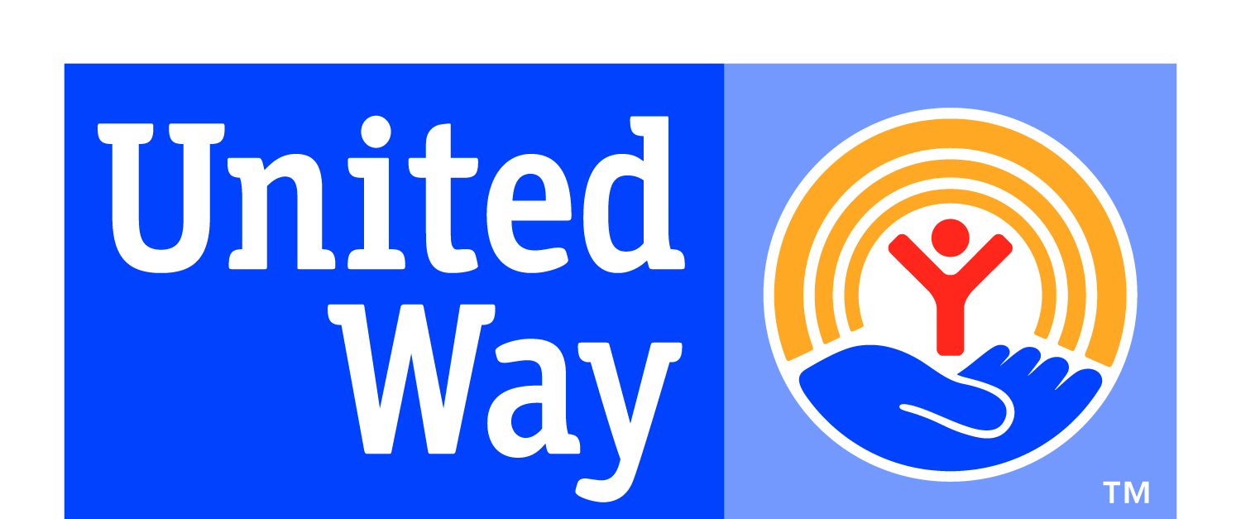
United Way End-of-Year Funding Report
March 2024–December 2024
DUE – January 16, 2025, before midnight EST

AGENCY: _________________________________________________________________________________
CONTACT: ________________________________________________________________________________
PHYSICAL ADDRESS: ______________________________________________________________________
MAILING ADDRESS: _______________________________________________________________________
TELEPHONE NUMBER: _____________________________________________________________________
E-MAIL ADDRESS: _________________________________________________________________________

List your 2024 funding distribution PER PROGRAM.

PROGRAM | TOTAL FUNDING  SPENT JAN-DEC | OVERHEAD  PERCENTAGE OF GRANT
1. | $
2. | $
3. | $
4. | $
5. | $
TOTAL SPENDING: | $

For each program listed above, please explain the results for the last 12 months of funding.
You will need to complete one chart below for EACH program. It is important to show what kind of impact these programs had on Daviess County or specific populations. If you are currently using the money for overhead, please note %
Number of Clients Served:
Age Range: (give percentages in applicable ranges)
0 – 18; 19 – 30; 31 – 40; 41 – 50; 51 – 60; 61 & up
GENDER BREAK DOWN:
Income Level: (Give percentages in applicable ranges)
Under $20K; $20,001 - $30K; $30,001 - $40K; $40,001 & up
RACE/ETHNIC BREAK DOWN IF KNOWN:
Average cost per client:
Other Notable Statistic or Changes to the organization as well as any further outcomes produced by your program:

ALL FUNDS WILL NEED TO BE SPENT BY END OF YEAR, UNLESS GIVEN PERSMISSION OF EXTENSION, BASED ON CERTAIN CIRCUMSTANCES.

